Name : Muhammad Qasim Ashfaq
Roll : SU92-BSAIM-S25-030
Student Data Set Information
This dataset contains comprehensive information on 2,392 high school students, detailing their demographics, study habits, parental involvement, extracurricular activities, and academic performance. The target variable, Grade Class, classifies students' grades into distinct categories, providing a robust dataset for educational research, predictive modelling, and statistical analysis.
Kaggle Link:
Data Set (Click Here)

Lab-Task 9
- Data Loading
- Introduction to Data Science
- Pandas , NumPy modules
- Displaying Data
- Data Exploration
- Performing tasks on the Data

Data Loading:
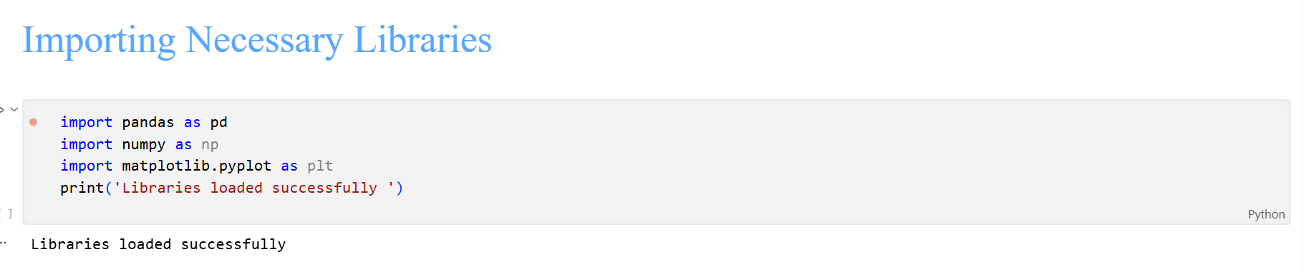
First, the important Data Science related libraries are imported
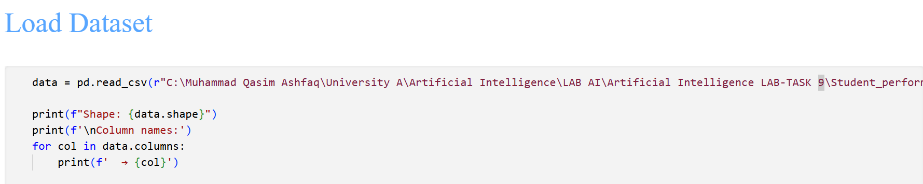
Then the dataset is loaded using pandas Data Frame and function “pd.read_csv(path)”
The Path is the Location of the directory in which the dataset file is present.

Displaying Data:
“data.head()”
Using this Function, we can display the data in an organized tabular Format.
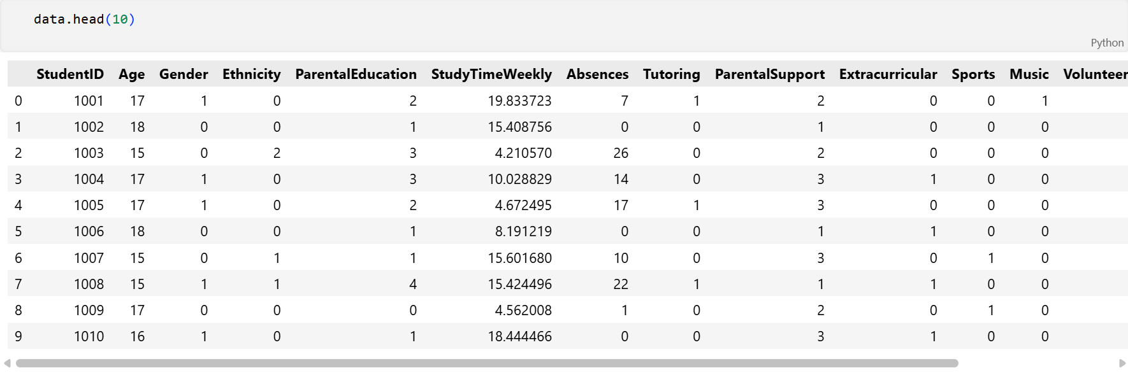
“data.shape()”
It Prints out the shape of the data in Pair Format (Rows,Columns)

“data.tail()”
Displays the last 5 rows of the dataset.
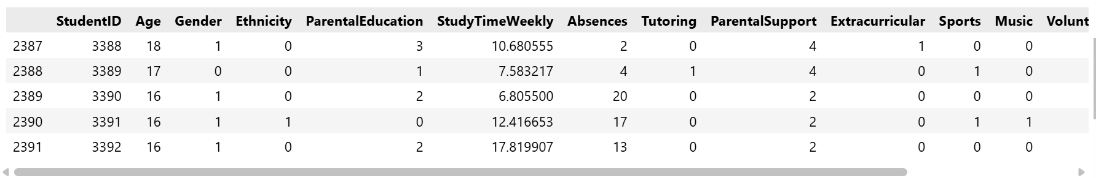

Datatypes and Data Structure:
data.info() is used to display the datatypes of various columns of data , how much memory the dataset is using and the overall data structure.
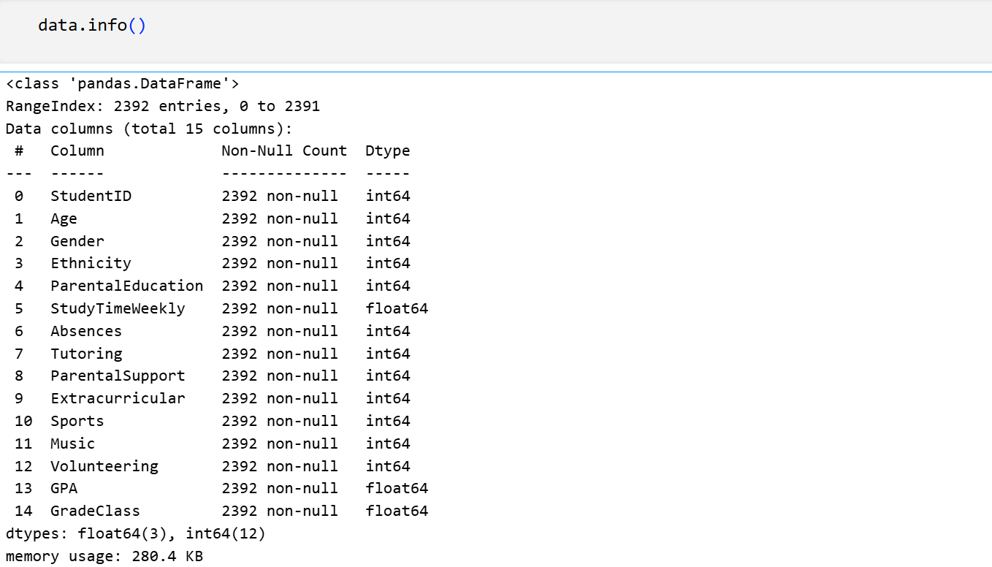

Using dtype Function:
